Network Fundamentals

Linux Fundamentals Part 1

**Task 1:**

No answer needed

**Task 2:**

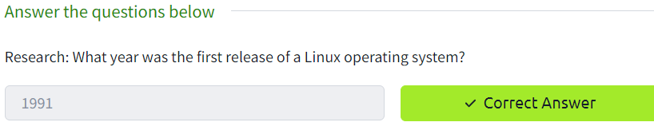

**Task 3:**

No answer needed

**Task 4:**

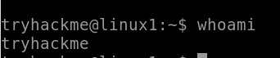

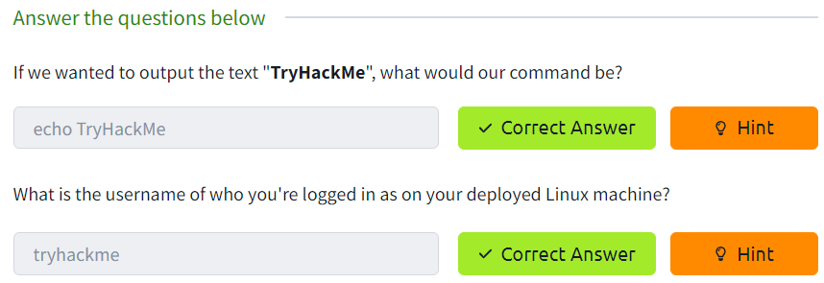

**Task 4:**

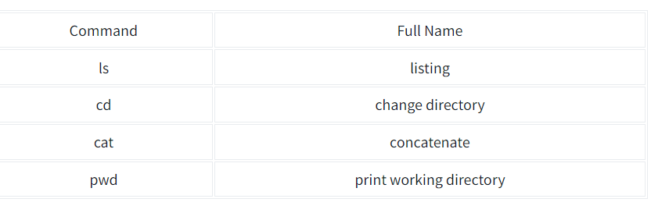

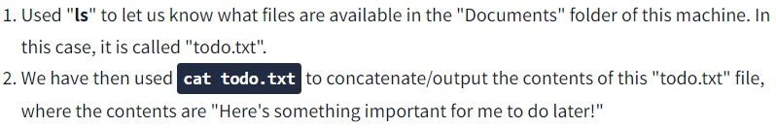

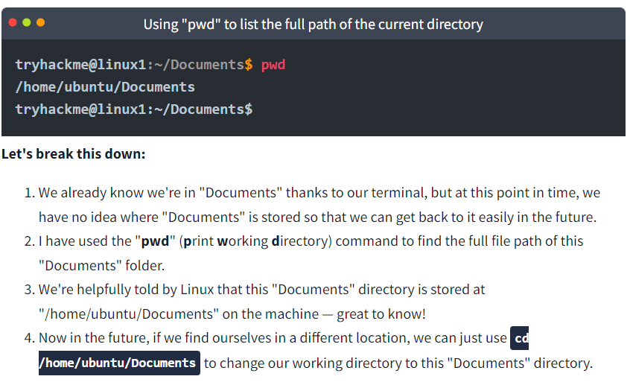

**Task 5:**

**Task 6:**